

Belvoir Archers   
The “Archer321 Shoot”

Saturday 23rd May 2026

**The shoot is open to all Archers who have not yet achieved their Bowman award badge and is based on the new 2023 ArcheryGB system**

**1st Classification Archers to shoot the National 50 (50/40 yards)**

**2nd Classification Archers to shoot the National 40 (40/30 yards)**

**3rd Classification archers to shoot the National 30 (30/20 yards)**

Belvoir Archers, Works Lane, Barnstone, Notts NG13 9JT

**( *what3words* location ///impulsive.mutial.shins )**

Field Captain Bryan Haynes

Lord Patron TBA

Assembly 1.30PM Sighters 1.45PM

Entry Fee £7

Closing date; 16th June 2026 or when full

**No Refunds will be given after the closing date.**

Rounds: National 50, National 40, National 30

Entries to; Bryan Haynes, 10 Harebell Gardens, Bingham, NG13 8TA

Email [tournaments@belvoirarchers.co.uk](mailto:tournaments@belvoirarchers.co.uk)

Awards Medals awarded 1st, 2nd and 3rd place  
 There will be separate awards for 1st, 2nd and 3rd class archers

Categories Longbow, Barebow, Flatbow, Recurve and Compound

Senior, Senior 50+, U21, U18 for both Gents and Ladies

All archers must show a valid ArcheryGB membership card when signing in to the tournament and may only shoot with proof of membership.

**ArcheryGB dress regulation 307 will apply.**

All archers under 18 must be accompanied by a Parent or Carer for the duration of the shoot.

**Data Protection** – When you enter competitions the following information may be collected and shared with tournament organisers, scoring systems and other competitors for example target lists and results may be published: First Name, Surname, Gender, Bow Style, Date of Birth/Age category, Email, Address, Phone Number, Club (and ID), County (and ID), Region (and ID), Round (unless defined by age), Disabled (Y/N), Disability info.

In accordance with GNAS Child Protection policy all wishing to take photographs or image recording must register with the Tournament Organiser.

If you are shooting all carbon arrows, you must inform the Tournament Organiser before you shoot. All arrow must be counted in and counted out.It is the Archers responsibility to ensure that all lost arrows are found before you leave the shooting ground.

Belvoir Archers cannot be held responsible for any loss or damage to personal property or vehicles at this event.

**Regrettably dogs are not allowed on the field.**

**No cars are to be parked on the side of the road** due to TARMAC lorries requiring access to the TARMAC Cement Works all day. Car Parking Attendants will be on hand to park you in the shooting field behind the tent line area.

**This event is sponsored by**

www.cbarchery.co.uk

**Belvoir Archers “ Archer321”**

**Sponsored by Custom Built Archery**

**Saturday 23rd May 2026**

**The shoot is open to all Archers who have not yet achieved their Bowman award badge and is based on the new 2023 ArcheryGB system**

**1st Classification Archers to shoot the National 50 (50/40 yards)**

**2nd Classification Archers to shoot the National 40 (40/30 yards)**

**3rd Classification archers to shoot the National 30 (30/20 yards)**

**VALID ArcheryGB / WORLD ARCHERY CARDS MUST BE SHOWN.        NO CARD  = NO INSURANCE = NO SHOOT**

|  |  |  |  |  |  |  |  |
| --- | --- | --- | --- | --- | --- | --- | --- |
| **Name**  Please indicate First and Second Name | **ArcheryGB**  **Number** | **Left or Right Handed**  **Archer** | **Special Requirements see note 1** | **Gender**  **M / F** | **Senior 50+ Adult U21 U18** | **Bow Type**  Compound, Longbow, Barebow, Recurve, Flatbow | **Classification 3rd Class**  **2nd Class**  **1st Class** |
|  |  |  |  |  |  |  |  |
|  |  |  |  |  |  |  |  |
|  |  |  |  |  |  |  |  |
|  |  |  |  |  |  |  |  |
|  |  |  |  |  |  |  |  |

Note 1 – please indicate if you have any special requirements such as a wheel chair or perching stool and whether they need to remain on the shooting line

Contact Details:

Name ___________________________________ Email ­­­­­­­­­­­­­­­­­­­­________________________________________________________________

CLUB ­­­­­­­­­­­­­­­­­­­­___________________________________ Telephone Number ______________________________________ Total Fee Paid _____________

Bank Transfer or Cheques payable to **Belvoir Archers**.

Bank Details on request

Entries to Bryan Haynes, 10 Harebell Gardens, Bingham, Notts. NG13 8TA.

**No Refunds will be given after the closing date of the shoot**.

**From A46 Newark**

**From Newark** take the A46 to Bingham and exit at the Saxondale Roundabout, follow the signs A52 towards Grantham. After 3/4 mile, turn right across the dual carriage way towards Langar.

Follow the country road to Langar.

As you leave Langar, turn left onto Coach Gap Lane, towards the Wildflower Farm.

Follow the road past the buildings for just over ½ mile, and follow the road to the left.

**Beware of the speed bumps**

Belvoir Archers shooting field will be on your left just before TARMAC Cement Works.

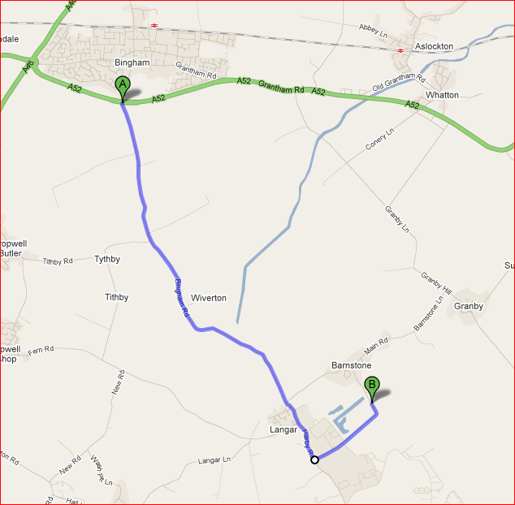

**From A52 Grantham**

Take the A52 towards Nottingham. Go past Bottesford. The A52 will then go into a 40MPH zone in Elton. Turn left roughly opposite the Pub/Indian Resteraunt.

Go through the village towards Sutton Cum Granby.

Go Straight over the cross roads, through Sutton Cum Granby and onwards to Granby.

At the Cross roads in Granby, turn right. As you leave the village, you will go down hill, turn left at the bottom towards Barnstone and Langar.

Go through Langar village, do not turn down Works Lane (this is where your satnav will take you, but TARMAC has asked us to keep traffic away from their works where large lorries are loading and turning 7 days a week).

You will leave Barnstone, and come to the cross roads at Langar, turn left.

As you leave Langar, turn left onto Coach Gap Lane, towards the Wildflower Farm.

Follow the road past the buildings for just over ½ mile, and follow the road to the left.

**Beware of the speed bumps**

Belvoir Archers shooting field will be on your left just before TARMAC Cement Works.

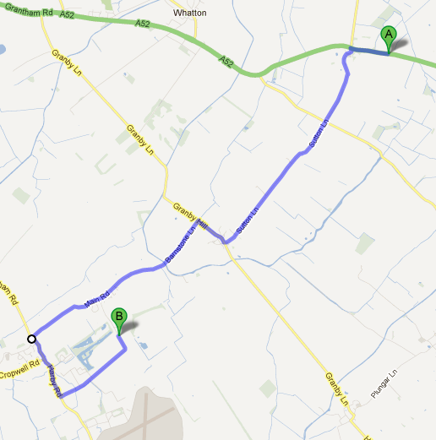**A52 from Nottingham**

Take the A52 towards Radcliffe and Bingham.

Go along the dual carriage way from Gamston round about for approx. 1.7 miles, past the petrol station and prepare to turn right at the traffic lights towards Cotgrave, Stragglethorpe and Cropwell Bishop

On the B Road, do not turn right to Cotgrave; instead follow the B road for around 7 miles through Cropwell Bishop to Langar

At the T junction in Langar, turn right.

As you leave Langar, turn left onto Coach Gap Lane, towards the Wildflower Farm.

Follow this road past the buildings for just over ½ mile, and follow the road to the left. **Beware of the speed bumps**

Belvoir Archers shooting field will be on your left just before TARMAC Cement Works.

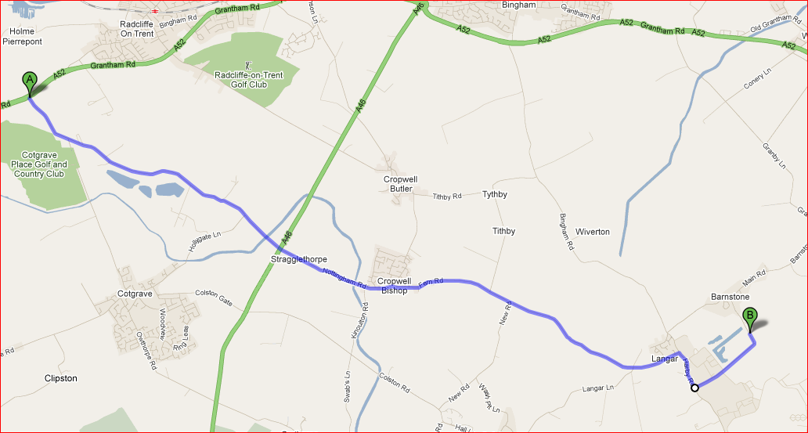

**A46 from Leicester**

Turn off the A46 at the Stragglethorpe / Cropwell Bishop Junction

Follow the B road through Cropwell Bishop to Langar – Approx. 4 miles

At the T junction in Langar, turn right.

As you leave Langar, turn left onto Coach Gap Lane, towards the Wildflower Farm.

Follow this road past the buildings for just over ½ mile, and follow the road to the left. **Beware of the speed bumps**

Belvoir Archers shooting field will be on your left just before TARMAC Cement Works.

