

Belvoir Archers 14th Summer Windsor
Saturday 1st August 2026

Belvoir Archers, Works Lane, Barnstone, Notts NG13 9JT
( what3words location ///impulsive.mutial.shins )

Judges Bernie Dicks, Michael Thomason

Lord Patron TBA

Assembly 10.45am Sighters 11am

Entry Fee £11 all age groups

Closing date; 19th July 2026 No Refunds will be given after the closing date.
Target List: A preliminary target list will be available on the Belvoir Archers and EMAS web site 3 days before the shoot starts.

Round: UK Record Status Windsor, Windsor 50/40/30
Shooting Method 2 – Timed Ends shooting 6 arrows
Single detail may be used if numbers are low.

Entries to; Bryan Haynes,
10 Harebell Gardens, Bingham, Notts, NG13 8TA 07887 633 121

Email: tournaments@belvoirarchers.co.uk

Awards Trophies awarded for Age Appropriate Round in the categories stated below, medals for 2/3rd depending on e ntries

Categories Longbow – U18, U21, Adult,. 50+ both ladies and gents
Barebow – U18, U21, Adult,. 50+ both ladies and gents
Compound - U18, U21, Adult,. 50+ both ladies and gents
Recurve – U18, U21, Adult,. 50+ both ladies and gents
Crossbow - U18, U21, Adult,. 50+ both ladies and gents

All archers must show a valid ArcheryGB membership card when signing in to the tournament and may only shoot with proof of membership.

ArcheryGB dress regulation 307 will apply.
All archers under 18 must be accompanied by a Parent or Carer for the duration of the shoot.

Data Protection – When you enter competitions the following information may be collected and shared with tournament organisers, scoring systems and other competitors for example target lists and results may be published: First Name, Surname, Gender, Bow Style, Date of Birth/Age category, Email, Address, Phone Number, Club (and ID), County (and ID), Region (and ID), Round (unless defined by age), Disabled (Y/N), Disability info.

In accordance with GNAS Child Protection policy all wishing to take photographs or image recording must register with the Tournament Organiser.

If you are shooting all carbon arrows, you must inform the Tournament Organiser before you shoot. All arrow must be counted in and counted out.It is the Archers responsibility to ensure that all lost arrows are found before you leave the shooting ground.

Belvoir Archers cannot be held responsible for any loss or damage to personal property or vehicles at this event.

Drug testing. The Shoot will be liable for drug testing, competitors approached to give samples must comply as refusal will be treated as a positive result. Parents/legal guardian of competitors under the age of 18 must sign the entry form giving consent to drug testing if required.

Regrettably dogs are not allowed on the field.

No cars are to be parked on the side of the road due to TARMAC lorries requiring access to the TARMAC Cement Works all day. Car Parking Attendants will be on hand to park you in the shooting field behind the tent line area.

This event is sponsored by

www.cbarchery.co.uk

Crossbows must adhere to AGB Rules of Shooting

- Rule 104. Crossbow Safety
  - (a) A crossbow may NOT be drawn or cocked except on the shooting line and in the direction of the targets, after the arbalist has ensured that the field is clear both in front of and behind the targets.
  - (b) If shooting is interrupted for any reason, crossbows shall be lowered immediately so that they are directed at the ground immediately in front of the shooting line and the bolt removed.
  - (c) No person less than 12 years of age may shoot or manipulate a crossbow.
- Rule 210. Crossbow
  - (a) A crossbow stock may be made from any safe material and must be fitted with a mechanical trigger. Prods, which may be made of any material except metal, shall not exceed 900mm in length when the crossbow is strung.
  - (b) The draw weight at the string latch shall be no more than 95lbs (43 kg). The draw weight and draw length must be clearly marked on the prod. The clean draw length, measured from the string to the string latch shall be no more than 300mm
  - (c) The bow must be fitted with a bolt retaining clip.
  - (d) A string may be made of any non-metallic material.
  - (e) Bolts may be made of any material and of such design as not to cause unreasonable damage to the target. Bolt length is minimum 12 inches, maximum 15 inches. Three fletchings, feather or plastic, shall be fitted.
  - (f) Telescopic or magnifying sights are not allowed.
  - (g) The following are permitted:
    - (i) Foot stirrups attached to the bow.
    - (ii) Stabilizers.
    - (iii) Palm rest.
    - (iv) A butt hook that does not rest directly on top of the shoulder and is no more than 150mm in length.
  - (h) The length between the back sight and the front sight shall not exceed 720mm.
  - (j) All crossbows must be drawn by hand. The use of cocking aids, gloves or fingerstalls is not permitted.
  - (k) Pistol crossbows are not permitted.
  - (l) Crossbow and the Law. When travelling on public transport or walking in a public thoroughfare it is essential that the prod be removed and the stock and prod be carried in a case or cover.
Crossbow competitors (arbalists) will shoot on their own boss, not mixed with other bow styles. They will shoot the round on a 60cm face 10-zone face scoring 9,7,5,3,1 with 4 individual faces on the boss. Each arbalist will shoot on their own face to reduce the risk of Bolt Damage.

All Crossbows are to be examined by the judge prior to shooting to ensure that they comply with the ArcheryGB rules of Shooting.
Belvoir Archers 14th Summer Windsor – Saturday 1st August 2026
Sponsored by Custom Built Archery

A parent or guardian of competitors under 18 years of age must sign to accept the entry conditions of the shoot and give permission for the named competitor to provide a urine sample for drug testing if approached.

ALL ARCHERS TO BOOK IN WITH THE CHECK IN DESK ON ARRIVAL.
VALID ArcheryGB / WORLD ARCHERY CARDS MUST BE SHOWN. NO CARD = NO INSURANCE = NO SHOOT

Name  Please indicate First and Second Name | ArcheryGB  Number | Club | Round  Windsor 60  Windsor 50  Windsor 40  Windsor 30 | Special Requirements see note 1 | Gender  M / F | U18, U21, Adult, 50+ | Bow Type  C LB R  BB XB | Parent / Guardian Signature

Note 1 – please indicate if you have any special requirements such as a wheel chair or perching stool and whether they need to remain on the shooting line

Contact Details:

Name ___________________________________ Email ___________________________________

Telephone Number _______________________ Total Fee Paid ____________________________

Cheques payable to Belvoir Archers. Bank Details on Request for Bank Transfer
Entries to Bryan Haynes, 10 Harebell Gardens, Bingham, Notts. NG13 8TA.
No Refunds will be given after the closing date of the shoot.
From A46 Newark

From Newark take the A46 to Bingham and exit at the Saxondale Roundabout, follow the signs A52 towards Grantham. After 3/4 mile, turn right across the dual carriage way towards Langar.

Follow the country road to Langar.

As you leave Langar, turn left onto Coach Gap Lane, towards the Wildflower Farm.

Follow the road past the buildings for just over ½ mile, and follow the road to the left.
Beware of the speed bumps

Belvoir Archers shooting field will be on your left just before TARMAC Cement Works.

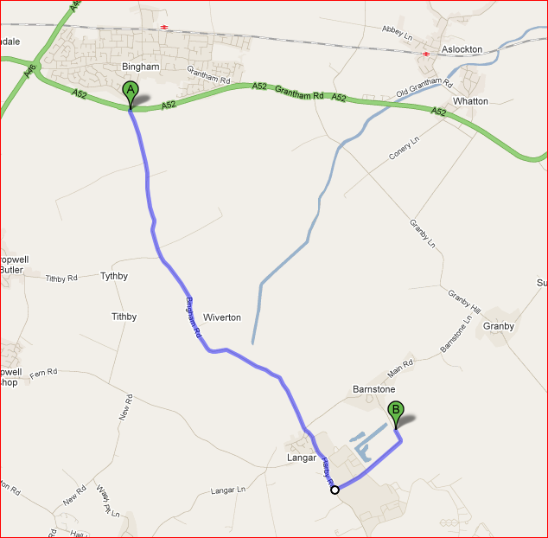

From A52 Grantham

Take the A52 towards Nottingham. Go past Bottesford. The A52 will then go into a 40MPH zone in Elton. Turn left roughly opposite the Pub/Indian Resteraunt.
Go through the village towards Sutton Cum Granby.
Go Straight over the cross roads, through Sutton Cum Granby and onwards to Granby.

At the Cross roads in Granby, turn right. As you leave the village, you will go down hill, turn left at the bottom towards Barnstone and Langar.

Go through Langar village, do not turn down Works Lane (this is where your satnav will take you, but TARMAC has asked us to keep traffic away from their works where large lorries are loading and turning 7 days a week).

You will leave Barnstone, and come to the cross roads at Langar, turn left.

As you leave Langar, turn left onto Coach Gap Lane, towards the Wildflower Farm.

Follow the road past the buildings for just over ½ mile, and follow the road to the left.
Beware of the speed bumps

Belvoir Archers shooting field will be on your left just before TARMAC Cement Works.

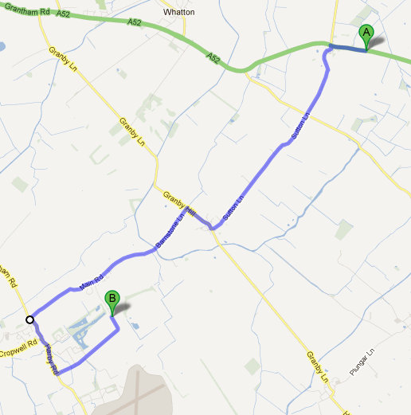
A52 from Nottingham

Take the A52 towards Radcliffe and Bingham.

Go along the dual carriage way from Gamston round about for approx. 1.7 miles, past the petrol station and prepare to turn right at the traffic lights towards Cotgrave, Stragglethorpe and Cropwell Bishop

On the B Road, do not turn right to Cotgrave; instead follow the B road for around 7 miles through Cropwell Bishop to Langar

At the T junction in Langar, turn right.

As you leave Langar, turn left onto Coach Gap Lane, towards the Wildflower Farm.

Follow this road past the buildings for just over ½ mile, and follow the road to the left. Beware of the speed bumps

Belvoir Archers shooting field will be on your left just before TARMAC Cement Works.

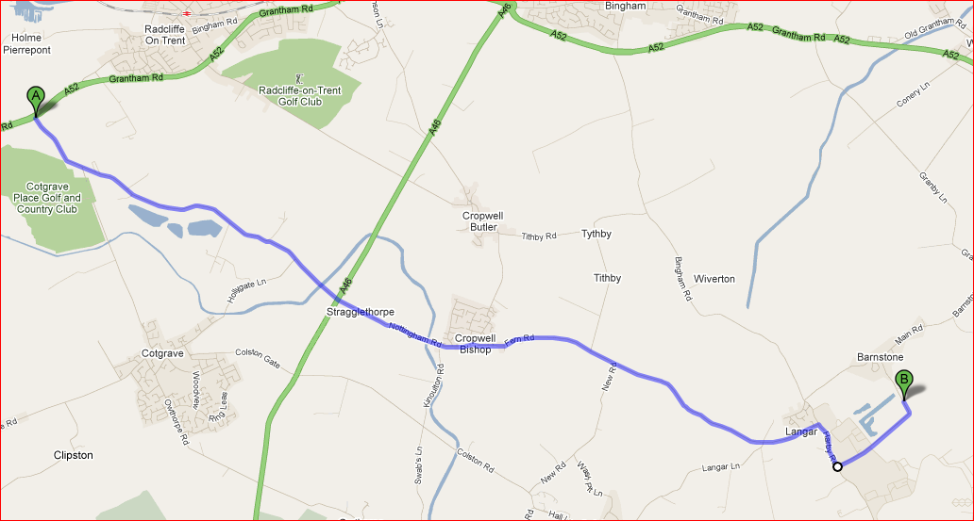

A46 from Leicester

Turn off the A46 at the Stragglethorpe / Cropwell Bishop Junction

Follow the B road through Cropwell Bishop to Langar – Approx. 4 miles

At the T junction in Langar, turn right.

As you leave Langar, turn left onto Coach Gap Lane, towards the Wildflower Farm.

Follow this road past the buildings for just over ½ mile, and follow the road to the left. Beware of the speed bumps

Belvoir Archers shooting field will be on your left just before TARMAC Cement Works.
